Executive Summary:
In the summer of 2005, a group of field session students were commissioned a task of creating lesson plans and an assessment test for a technology-based camp geared towards underprivileged students. The camp was formed in response to our clients’, the graduate students, desires to increase the interest of students towards technology at a young age. Our team has both written and taught the lesson plans and assessment test for two camps, one camp composed of both boys and girls and one camp composed entirely of female students. After teaching the camps, our team has adjusted the lesson plans and assessment test to allow for smooth teaching of the coursework. By analyzing the assessment test, we found little evidence to support our original goal, seeing how girls learn differently in a segregated group. The lesson plans were meant to be fun but informative, light but with complexity. The assessment measured the students’ interests, skill level with computers, and their previous experience with computers. The drawbacks of the study were the small camp size, small time frame for teaching, and no long-term assessment of the students. In conclusion, our team has learned much in the field of education to middle school students, but statistically, the results were insignificant. Our study does indicate, however, a positive increase in the attitude of the students that we feel is encouraging to future studies.

Tech Camp 101:
Final Project Report

Submitted to:
Dr. Rader

Prepared By: Mike Way, Katie Hayden, and Jason Golloher
On June 23, 2005

Table of Contents

Abstract __________________________________________________________________ 2

Introduction _______________________________________________________________ 2

Requirements and Specifications _______________________________________________ 3

Solution Approach __________________________________________________________ 4

Implementation ____________________________________________________________ 5

Data Analysis ______________________________________________________________ 9

General Observations _______________________________________________________ 18

Conclusion and Future Directions _____________________________________________ 20

References _______________________________________________________________ 21

Figure 1: Tech Camp 101 Schedule ____________________________________________ 22

Figure 2: Layout of Project __________________________________________________ 23

Figure 3: Tech Camp Plan ___________________________________________________ 24

Appendix A: Games Factory Lesson Plan _______________________________________ 25

Appendix B: Rocket Science Lesson Plan _______________________________________ 34

Appendix C: Assessment Test ________________________________________________ 42

Appendix D: Math Magic Lesson Plan _________________________________________ 47

Appendix E: Assessment Test with Likert Scale __________________________________ 50

Abstract:

Our goal for the Tech Camp 101 is to educate primarily minority and female middle school students in various areas of computer technology. We are delivering lesson plans that create fun interactive ways to learn new skills in computer science. We have also implemented a creative way to assess the students' progress during the week long camp.
Tech Camp 101 focuses on teaching students three different interactive programs that enhance computer learning in the areas of robotics, movie making, and video game development. We monitored and taught the students the basics of Alice, Games Factory, and Lego Mindstorms.

Introduction:

The purpose of this document is to provide our group’s understanding of, implementation, and analysis of the Tech Camp 101 project for field session 2005. Our goals were to devise lesson plans for the technological material covered in each camp as well as actually teach our lesson plans to two groups of middle school students during these camps. The first week will be a co-ed group of students, whereas the second is limited to females. We also wanted to develop an assessment test for the students to take that would measure their attitudes toward technology as well as their knowledge and skills with computers.

Background:
In the summer of 2004, a free pilot technology camp was offered to underprivileged middle school students called Tech Camp 101. The camp was funded in part by the National Science Foundation (NSF), specifically the GK-12 Learning Partnerships: Creating Problem Centered, Interdisciplinary Learning Environments grant. This grant funds a three-year program that was created in August of 2003, with seven graduate students and seven science or mathematics middle school teachers. Graduate students, also called fellows, from the Colorado School of Mines were placed as teachers’ aides to assist the instructors. As fellows in the GK-12 Learning Partnerships program, each graduate student devoted 15 hours each week assisting middle school science and mathematics teachers in their classroom throughout the year.
During the time spent at the middle schools, the graduate students realized that a summer camp that taught the children about technology while still entertaining them would provoke an earlier understanding and interest in technical fields. Upon learning that such camps were often too expensive for the students to attend, the graduate students decided to host their own camp. Our clients, the graduate students, have asked us to help provide a set curriculum that can be easily followed and taught to the kids during the camp by other college-aged students.

Requirements and Specifications:

Lesson Plans:
We were assigned the task of creating and teaching lesson plans for both the Games Factory video game program and a rocket science unit, where the students could actually make their own bottle rockets and launch them. In addition, the lesson plans we were assigned to help teach for the camp will cover the Alice movie-making program, the Lego Mindstorms robotics program, a lesson in cryptography, and a project involving the innards of a computer. As a final task, we were responsible for coming up with various small time-fillers, which could be used to calm the students down at the end of the day. All of these plans should be as detailed as possible, and include a short introduction for the students, teacher’s notes for installation and use of the programs involved, and a small user’s guide to cover most questions that students may ask during their work time. These plans are to be delivered in the final project as the focus of our work. In addition to these plans, our group is developing an assessment test to determine the student’s progress intellectually and emotionally. With the assessment test, our group hopes to see an increase in the students’ interest in technological fields.

The Programs:
Alice is a 3D graphics-programming environment intended to be a gentle introduction to students ranging from 6th grade to college. It is designed for students who typically would not take a programming course. The goal of the Alice project is to change the initial experience students have with computer programming. Alice is designed to change the experience of learning to program in two main ways: removing unnecessary frustration and providing an environment in which beginning students can create programs they find compelling.
The Games Factory, like Alice, is a program designed to show kids from 6th grade and up that programming can be fun and interactive. The program creates amazing games without any actual coding. The Games Factory is a complete development package for creating games and applications just by using your mouse to point and click. Students can easily develop games or screen savers using a simple interface and test them with a click of the mouse, making the process quick and fun.
The Lego Mindstorms project provides a forum for children to develop an understanding of and extend their interest in the field of robotics. Just like the two previous programs, the goal of Mindstorms is to enhance the learning of 6-8th graders with its simplistic programming techniques. The students will build robots in order to solve a problem, such as helping a disabled person with common household chores. After creating their robot, the students will also program the robot using a simple drag and drop interface. Again, testing for the robots’ programming is extremely easy and fun for the user, making the program ideal for younger students.

Rocket Science:
In order to further diversify the learning experience we will implement a rocket science project. We will be using computer simulations to demonstrate projectile motion using Newton’s third law of motion. In addition, we plan to deliver basics of force and pressure with other hands-on demonstrations. The project will conclude with the students launching their own rockets.

Assessment:
Our goals for the assessment portion of the camp include:
- Trying to get an understanding of the background of the students
- Assessing what they already know about computers
- Getting an idea of their views of technology
We plan to do this with a multiple-choice format of assessment. During the assessment we need to be careful to keep the students from influencing each other’s answers. Also, the wording of the questions will need to be as unbiased as possible. We will attempt to create a test that will give an accurate picture of what the students views of technology are before the camp, and how, or if, they’ve changed by the completion of the camp. As a group, we are especially interested in looking at the results of the second week of the camp. We hope to see a strong increase in interest among the female students since recent studies have shown a decline of females in technological fields.

Teaching:
Our biggest focus for this project will be the implementation of our lesson plans at two one-week camps. From 10am to 3pm, we, as well as our clients, will be presenting to the students the material our group has developed. The instructors will cover a different technological topic on each day of the camp. The instructors will make sure to give the students time to discover the program at their own level, while still giving them a broad base from which to start their work. During the students’ independent time portion, instructors will monitor them and answer any questions that they may have. The final day of the camp is allocated to the students. They will be able to work on their favorite program, giving them time to complete the project and possibly show it to their parents at the open house, the final event of the camp. As a group we are responsible for knowing how to use all the software, but we will be teaching Games Factory, bottle rocket science, and the assessment. The graduate students will administer Alice, Mindstorms, cryptography, and show the students the inside of a computer. Once the camps have finished, and our assessments have been completed and analyzed, our group will reevaluate our lesson plans, include any possible revisions, and submit them as our final project. The schedule for the camp is attached as Figure 1.

Solution Approach:

The purpose of this section is to outline the design preparation for teaching the lesson plans for the Games Factory program, rocket science project, math magic activity, and assessment plans. The lesson plans for both the rocket science project, and the computer programs will be formatted the same way. The lessons will start by introducing the activity to the students through a simple presentation done by the head of the project. The presentations will mostly be interactive, allowing the children to see the program working as well as letting them work along with the presenter. After the presentation, the presenter will give the children a task, and the students will be given the rest of the time to create a solution to the problem in their own style. Each lesson plan will be given at least a two-hour block of time, with the exception of both the wrap up activities and the assessment test. These two activities will take between 15-30 minutes each, and will be primarily presentation based. Attached are two Gantt charts displaying the time management of both the tasks for field session (Figure 2) and the tasks we will be responsible for teaching in the camp (Figure 3).

Games Factory:
The video game program, Games Factory, will be used as a tool to show how creative and visual game programming can be. By eliminating the syntax of the code and focusing on the ideas used when programming, children are exposed to analytical thinking and logic. The visual cues used by the program also make the testing process more fun for the student and comprehensive for the tester. The actual lesson plan is attached to the report as Appendix A.
The video game project for the camp is scheduled for two hours on Wednesday, or day 3, of the camp at the beginning of the day. The goal of the project however, is to interest the students enough to want to continue working on their games on their free day of the camp. The presentation and introduction of the software to the students is expected to last twenty minutes, with the remaining time given to the students to either develop the Springy game or change the Breakout game.

Rocket Science:
The rocket science project is a new idea this year, which will be implemented in place of a computer graphics tutorial. Our group wanted to make use of the summer season, as well as show that technology is not purely practiced indoors. By giving the students another hands-on activity that is outdoors, our hope is to show that science is not exclusively practiced in the laboratory. The lesson plan for the rocket science project is attached as Appendix B.
The rocket science project is scheduled for the second day of camp, or Tuesday, in the afternoon. The project has been allotted two hours time for both presentation and student work time, with additional time given on the fourth day of camp for the launching of the rockets. The presentation of the project will take approximately twenty minutes, with the remainder of time given to the students to design their rockets. The goal of the rocket science project is to teach the children a fundamental basis of forces and pressure and give an introduction to the scientific method. The only risk associated with the rocket science project is inhospitable weather conditions. If the weather does not cooperate, the schedule for launching the rockets will be shifted to a time of clearer, sunnier skies, and other activities will be changed accordingly.

Assessment:
For the assessment portion of the camp, we will administer both a pretest and a posttest to the students to determine their progress throughout the camp. Two questions will cover each project explored during the camp, illuminating for us what the students have learned after attending the camp. In addition, five background questions will be included, telling us how much experience the students have had with technology before our camp. Finally, we are including ten technological interest questions, which we will use to monitor how their interest increased or decreased because of the camp.
The only thing needed to administer the tests will be the Personal Response System (PRS); it will be used to store the answers given by each student during the test.
Beginning/ End of Course:
- An onscreen projector will be used to display the Pre/Post Test to the student.
- PRS remote clickers will be assigned to the students to record their answers. The students will choose 1 for yes, 2 for no or 1 for A, 2 for B, 3 for C and 4 for D. Simply press the number on the keypad for the desired answer.
- The questions will be read aloud by the presenter. When taking the test it is essential that there is absolute quiet, and that the students are not exchanging their answers with each other.
- The students will have an hour to complete the test.
The same preparations and implementation will be used for both the tests to ensure uniformity throughout the testing process. The actual test that will be given to the students is referenced in Appendix C.
The assessment portion of the camp will be implemented at the beginning of the camp as well as the end, with an hour being allotted to each test. The pretest will be administered after introductions and icebreakers on the first day of camp, Monday, and the posttest will be administered on the last day of camp, or Friday, as the last activity. The test has to be as unobtrusive as possible, while still providing a scientific basis for which to study the students’ understanding and interest in technology. It is the goal of Tech Camp 101 to increase the students’ knowledge of, and interest in technology. There are two risks associated with the completion of the assessment plan for the camp: the use of remote control clickers if the network fails, and the questions being too unambiguous, leading to results that are unusable. If the network fails to respond to the clicker software, hard copies of the tests will have to be administered to the students. In the case of hard copies being implemented for the assessment the questions will still be read aloud by the presenter.

Math Magic:
The math magic activity can be implemented as a wrap up activity at the end of the day. The idea behind the activity is to give the children something easy to recreate to their friends and family, while still being math-based in its workings. In addition, the wrap-up activity serves to bring the students back together after a period of independent work. The lesson plan for the math magic activities is attached as Appendix D.
The math magic activities have been scheduled for the end of days one, two, and four. Each activity will be given approximately fifteen minutes, with the whole of the time being allotted to the presentation. This presentation though, is interactive with the students, and is intended as a final activity for the day’s work. When presenting in the previous year, our clients found that students typically became restless at the end of the day. The goal of the math magic activities is to teach students simple algebra skills while entertaining them. The only risk to the implementation of the math magic activities is a lack of time during the camp to implement them.
This lesson was cut from implementation in both camps because the students were extremely focused and interested in the projects presented, but we have retained the lesson plan for future camps in case the need arises.

Implementation and Results:

Rocket Science:
The implementation of the rocket science unit followed the materials list and procedure laid out in the lesson plan in Appendix B. The rocket science project was scheduled for the second day of camp, or Tuesday, in the afternoon. The project was allotted two hours for both presentation and student work time, with additional time given on the fourth day of camp for the launching of the rockets. The presentation of the project took approximately ten minutes, with the remainder of time given to the students to design their rockets. During the launching process students were able to experiment with a number of combinations of amount of water and pressure. This allowed them to test in the field as well as experiment in the computer lab. In conclusion to the unit, students reviewed the results of the launch and brainstormed reasons for inconsistencies with the model they received with the software. Also, students discussed ways in which they could have been more systematic about experimenting with their values. Such as leaving one value constant and adjusting the other one and observing the differences.
During the initial implementation of the lesson plan a few problems arose. The first problem is that some of the students did not understand the basics for pressure and force. But because so many students did understand, the presentation proceeded at a pace that was too fast to ensure that all students truly understood. The next area that needs some adjustment is to add more information before allowing students to work with software. Students seemed to be confused initially as to what they were doing with the program. A more lengthy discussion of what is expected of them and the differences throughout the program could be beneficial. Another problem area became apparent when the students were asked to calculate the amount of water they should use based on the percentage they chose in the program. Students didn’t understand the basics of percentages and a brief presentation would be useful instead of explaining the concept to individual groups. Overall the first implementation of the lesson plan seemed to go well.
The second week of the implementation also had a few problem areas. For one, the launcher did not work as well as expected. It began leaking at 40 PSI and many of the rockets shot off sideways before students had a chance to release their rocket. These issues are due to wear from the first week’s launching. Recommendations for alleviating these issues are that in-between weeks the stopper and pin that holds the bottle in place, should be replaced. Also, the metal mounting plate should be made out of a thicker, or stronger material that will not bend easily even under the pressure of pushing the bottles into place. All of these issues have been addressed in the lesson plans.
Another problem that became more apparent during the second week of implementation is that students had difficulty calculating their height. They were given a formula in which they needed to substitute their particular time into, and still they needed help accomplishing this task. They had difficulty understanding the basics of algebraic expressions. A more thorough discussion of the height formula will be beneficial to students in future implementations.
One last issue with the second group of students was holding their attention and generating enthusiasm for the project during the launching. The girls seemed to not be as excited and therefore less interested in further experimentation with their rockets. The launcher not working probably aggravated this. Since they did not collect as much data, it was difficult to discuss proper experimentation techniques. Proper building and testing of all the equipment used during the project will help the children stay focused on their task. Overall, the second implementation showed an improvement in understanding for the students, but it appeared to be less of an improvement for getting students interested in this particular hands on experimentation.

Games Factory:
The video games lesson plan was taught on the third day of camp, or Wednesday, during the morning block of time, between 10 am and noon. The introduction and walkthrough of the first game lasted about 45 minutes, with the remainder of the morning block allocated to the teacher’s option of students’ free time, further instruction of the optional activities, or a combination of both. The lesson plan is broken into bulleted sections to allow easier reading for both the student and the teacher. Printing the lesson plan for the students is necessary due to the lesson’s length and complexity. By allowing the students to go faster or slower using the paper copies of the plan, the students were able to learn at a comfortable pace no matter their skill level. Other instructors were free to roam the classroom to assist the students during their free time and the instruction.

Changes to Implementation:
After one week of the camp, some changes to the lesson plan were necessary to accommodate the students as well as provide more background to instructors unfamiliar to the Games Factory program. As a result of watching the children’s interest in the online video games during the first week of camp, our group has added a tutorial explaining to the students how to add shooting into games. In addition, due to the length of the first tutorial, the lesson plan was broken into more pieces, allowing for quicker instruction. The extraneous parts of the Breakout game were put into the optional activities section, as well as the Springy game. Finally, as a simple skill for the students to use a sentence structure breakdown of events for the games has been added to the plan. By having the students write out what they want to happen each time, the events editor becomes much easier and less intimidating to use.
Our group is confident that these changes to the lesson plan will allow future teachers easier instruction and use of the program. By using clear but, thorough instructions, students and teachers now have a lesson plan that both can enjoy while learning about an area of technology.

Assessment:
For the assessment portion of the camp, we administered both a pretest and a posttest to the students to determine their progress before and after attending the camp. Questions covered each project explored during the camp, students’ interest in technology, and the students’ background using computers. The content questions illuminate for the instructors what the students have learned after completion of the camp. The background questions tell how much experience the students have had with technology before the start of camp. The technological interest questions are used to monitor how or if the students’ interests changed after the completion of camp.
The assessment test was given to the students on both the first day (Monday) and the last day (Friday) of the camp. The pretest was given immediately after introductions and rules had been laid out, usually around 10:30 am. The posttest was given to the students on Friday morning as the first lesson of the day. The assessment test takes about half an hour to administer. The PRS system was the main tool used to administer the test, with the students using remote clickers to answer each question. During both tests, the administrator stood near the screen, reading the question and possible answers to the students. A helper was used to both start the PRS timer for each question and scroll between the questions. The administrator read each question and all the possible answers and then signaled the helper to start the timer. Students were allowed to see when they have answered the question by looking at the screen, but they were not allowed to see their answers.

Changes to Implementation:
To comply with traditional scientific rules, all test questions were made to be as unassuming and fair as possible. In addition, both the questions on the test and the answers for each question were randomized, ensuring no subconscious hints to the students.
Due to our clients’ wishes, the assessment test was changed to include more technological interest questions and less content questions. Also, the length of the test was changed to include two more questions, one that does not use the clickers.
Our group feels that these changes to the assessment give the instructors a more accurate picture of the interests and skills of the students attending the camp. The assessment will also determine if the students learned anything during the weeklong session.

Data Analysis:

The following sections describe the goals, assessment material, data collection, data analysis, observations and conclusion from the two sessions of the camp.

Objective:
We are trying to determine if a technology based camp given to underprivileged students will increase their interest in technology and technologically based fields of work and study. We are also trying to determine if girls learn better when they are segregated from the opposite sex. If these goals are met then we would like to implement them in future camps to further the educational experience for girls and underprivileged students.

Assessment Materials:
The students were given a pre/post test to determine their attitude, background and technical ability with a computer. We used these categories to derive a system of evaluating the students’ knowledge and attitude before and after tech camp. We found that the attitude category of the test was too broad, so we subdivided the category into three subcategories: skills, personal interest, and image of a computer scientist. Skills conveyed the students’ attitude toward their skill level to use a computer, while personal interest expressed the students’ personal interest in computers. Image of a computer scientist displayed how the students’ felt about computer scientists. We also felt by adding the subcategories our data would be more accurate when evaluated. Next, we randomized the questions and answers to insure that the test was as unbiased as possible. This was done using the website http://www.random.org which is a random number generator.
The test questions were displayed in Microsoft Word via projector to ensure that the students’ undivided attention was maintained throughout the testing process. To answer the questions the students used the personal response system (PRS) or otherwise known as clickers. The PRS system was displayed on the same screen above the Word document to show the instructor and the students how much time was left for answering a given question. The projected PRS system would also tell the instructor if everybody had answered the displayed question in the allocated time. The clickers are hand held remotes that have a number pad on them. When a question is displayed the student would enter their answer on the clicker keypad; 1 denoted a YES response, 2 for NO, as well as questions ranging from 1 through 6 of general multiple choice format.

Data Collection:
Data was obtained from middle school students with underprivileged backgrounds in Adams County District 50. The schools that were involved were Clear Lake, Shaw Heights and Hodgkin’s. The first camp was mixed gender with 11 boys and 4 girls, 15 total while the second camp had all girls, 12 total. The mentors of the camp, based on student applications selected the students. The mentors selected students that had a strong interest in technology and had a desire to attend a technology based camp.
The pre/post test was the main form of data collection used in each camp. Our mentors designed the pre/post test questions and they covered the students’ attitude toward computer science, the students’ background in computer science and content questions from the programs taught during the camp.

Data Analysis:
- CATEGORIES- The analysis for the pre/post test began with subdivision of the test questions into categories that could be analyzed. The attitude questions represented the qualitative category so they had to be put into a quantitative state in order to be analyzed. The three subcategories for the attitude are: skills, personal interest, and image of a computer scientist. Skills expressed the students’ attitude toward their skill level to use a computer, while personal interest displayed the students’ personal interest in computers. Image of a computer scientist showed how the students’ felt about computer scientists. We also made categories for the quantitative states like background and technical ability of the student associated with computers.
- TRUSTWORTHINESS OF THE QUALITATIVE CATEGORY- Since we had to make additional categories for the attitude section of the pre/post test questions, we had to include trustworthiness as one of our factors in analysis. We did this because the attitude category had qualitative response questions. Trustworthiness is a measuring model by which we have accurately determined the events and settings of the camp. We have insured trustworthiness by separating our team members and each of us making our own categories for the pre/post test. When we reunited we found that most of the questions were put in the same categories. The questions that were not put in the same category were revaluated and if no category could be made for them the questions were then thrown out. The group threw out three questions because we couldn’t come to an agreement on how to evaluate them. If a student took the pre test but not the posttest or vice versa the data from that student was discarded.
CATEGORY | QUESTION
Personal Interest | - Do you want to go to college after high school?  - I like working on the computer?  - Choose the statement that best describes you?  - I want to be a computer scientist when I grow up?  - I like computer science?  - Which of the following areas is your favorites?  - I want to go to college in math or science when I’m older?
Skills | - Do you think computer programming will help you in college?  - I am good at using a computer?  - What is your skill level on a computer?
Image of a Computer Scientist | - Computer scientist help people?  - Computer scientists are nerdy?  - Most computer scientist’s work by themselves all day?
Technical ability | - What is the most important step when programming a video game?  - Today, binary code is a form of cryptography, but what is it used for?  - What type of file is a video game usually saved as on a computer?  - Why do straws work?  - What will the bunny code below do?  - If you were to jump off the end of a skateboard, it would travel in the _______ direction of your jump?  - The most common problems in computers occur because a cable is not connected in the right location. Which one of the following changes to computer cables does not help avoid this problem?  - The central processing unit (CPU) on a computer is most similar to?
The table below lists all the evaluated categories and shows the final placement of the questions.

- ANALYSIS OF CATEGORIES- After the questions were sorted into their categories, we then used the Likert Scale to determine the values for each answer. Then we used that value to determine the p-value by using the two-tailed t-test. We repeated this process for all four categories. Our goal is to see if we can reject the null hypothesis that the mean scores between the pretest and the posttest are equal for each category that we are evaluating.
H₀: _{pre} = _{post}
H₁: _{pre} ≠ _{post}
Likert Scale-The pre/post test questions were then separated into their categories and the answers to the questions were then assigned a numerical value. The numerical values ranged from 1 through 5, 5 being the highest value of importance in the Likert scale. The Likert scale was used because it gave a quantitative approach to determining the value of a qualitative response. The complete list of assigned values can be found in Appendix E. Below is an example of the Likert scale that was used to determine the values for a qualitative response.

Please indicate your agreement with the following statement.
Computer scientist help people? Assigned Numerical Value
- Strongly Agree 5
- Agree 4
- Neutral 3
- Disagree 2
- Strongly Disagree 1
In this case, we observed the best possible response to be “strongly agree,” so we placed it as the highest value. Conversely, we observed a “strongly disagree” answer to be the worst possible response, so we gave it a value of one. The value zero was not used in the scoring because the answers are opinions.
For the quantitative questions we used the same process, the Likert scale. Below is an example of a quantitative response. By quantitative we mean that there is an incorrect or a correct response to content questions. If the student chooses the right answer a 1 value is given, a wrong response will give a 0 value. Below is an example of how the Likert Scale works.

What is the most important step when programming a video game?
Assigned Numerical Value
- Making the game colorful 0
- Adding cool objects 0
- Exploding things 0
- Testing the game 1

Two Tailed T-Test-After using the Likert scale to determine a value for each answer to the given questions in the pre/post test we then found the probability value (p value) using a two tailed t-test. We found these values by first adding up the Likert scale values found in the data from above for each question. We then found the mean of each question for each student on the pre and posttest. We did this by adding up all the numerical values for each answer for each question and then dividing by the number of students. Then we found the percentage of points found in the given category, this was done by taking the students’ Likert scale score and dividing by the number of possible points in each category. After finding the percentages, we found the p-values by making an Excel spreadsheet with pre/post test percentages from each category for each student. While still in Excel, we then used the “insert” function option in the tool bar, and then using the statistics function, we made a two-tailed t-test. We made our first array the list of percentages for the pretest. For the second array, we used the list of percentages for the posttest. We then selected the tails array and selected two for the type of test we wanted to use. After that, we selected two-sample unequal variance by picking the third option for the samples. Once we found the p-value we compared the data to an alpha level of 0.05, which is a standard test level for significance.

Category | Pretest (score/total possible) | Posttest (score/total possible)
Technical  Week One  Week Two
  0.8750
  0.7500
  0.7500
  0.3750
  0.8750
  0.1250
  0.5000
  0.6250
  0.7500
  0.6250
  0.2500
  0.6250
  0.3750
  0.3750
  0.3750
  0.3750
  0.2500
  0.6250
  0.3750
  0.5000
  0.5000
  0.5000
  0.5000
  0.8750
  0.6250
  0.7500
  0.7500
  0.7500
  0.3750
  0.6250
  0.6250
  0.6250
  0.6250
  0.8750
  0.8750
  0.6250
  0.7500
  0.6250
  0.6250
  0.6250
  0.8750
  0.6250
  0.7500
  0.5000
  0.7500
  0.6250
  0.6250
  0.8750
  0.6250
  0.7500
Skills  Week One  Week Two
  1.0000
  0.7273
  0.6364
  0.5455
  0.8182
  1.0000
  0.8182
  1.0000
  0.8182
  0.9091
  0.3636
  0.8182
  0.4545
  0.8182
  0.6364
  0.8182
  0.8182
  0.9091
  0.6364
  0.6364
  0.5455
  0.8182
  0.8182
  0.7273
  0.9091
  1.0000
  0.6364
  0.7273
  0.9091
  0.8182
  1.0000
  0.9091
  1.0000
  0.9091
  0.9091
  0.7273
  0.8182
  0.5455
  0.8182
  0.3636
  0.9091
  1.0000
  1.0000
  0.6364
  0.8182
  0.6364
  0.8182
  0.9091
  0.7273
  0.5455
Personal Interest  Week One  Week Two
  1.0000
  0.4800
  0.8400
  0.6800
  0.7600
  0.7600
  0.9600
  0.9200
  0.9600
  0.9600
  0.4400
  1.0000
  0.5200
  0.6800
  0.7200
  0.8400
  0.7200
  0.8400
  0.7600
  0.7200
  0.7600
  0.8400
  0.8400
  0.7600
  0.9600
  1.0000
  0.8000
  0.8400
  0.5200
  0.8400
  0.5200
  0.8400
  0.9200
  0.9600
  0.8800
  0.6800
  0.9200
  0.7200
  0.7600
  0.7200
  0.8400
  0.8400
  0.8400
  0.8400
  0.7600
  0.6800
  0.8800
  0.8000
  0.8400
  0.8000
Image of a computer scientist  Week One  Week Two
  0.7333
  1.0000
  0.8000
  0.2000
  0.6667
  0.7333
  0.6000
  0.8667
  0.6000
  0.7333
  0.5333
  0.6667
  0.6667
  0.8667
  0.8667
  0.8667
  0.6667
  0.8667
  0.8667
  0.8000
  0.7333
  0.8000
  0.8667
  0.6000
  0.8667
  1.0000
  0.8667
  0.8667
  0.2000
  0.8000
  0.6000
  0.7333
  0.7333
  0.6667
  0.7333
  0.6667
  0.6000
  0.8000
  0.6667
  0.6667
  0.9333
  0.7333
  0.9333
  0.8000
  0.8667
  0.7333
  0.8667
  0.8000
  0.6667
  1.0000

The data above shows some interesting facts about the categories from the pretest to the posttest. For instance, in the technical ability category week one had higher test scores than week two. Week one was seven percent higher that week two; one of the reasons for this is that three of the students had taken this same tech camp last year. In week two no one had been to tech camp, so their knowledge base for the technology we taught is lower. However, week two showed a twenty percent increase, a better improvement than week one which had a twelve percent increase. Since the week one students started at higher values they were limited in the amount they could increase their scores. Having week two students start at a lower score gave them more room for improvement. A graph summarizing the changes can be seen below.
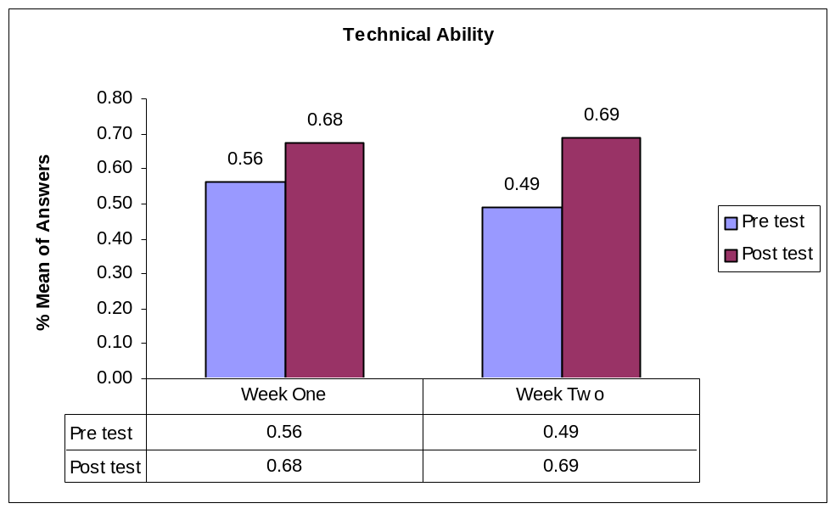

When it came to the skills portion of the pre/post test, week one showed more improvement than week two. Week two only had a one percent increase while week one had an eight percent increase. The skill questions on the pre/post test are what the students think of his/her skill level and we were hoping to see a dramatic increase for week two rather than week one. The percentages can be seen below.

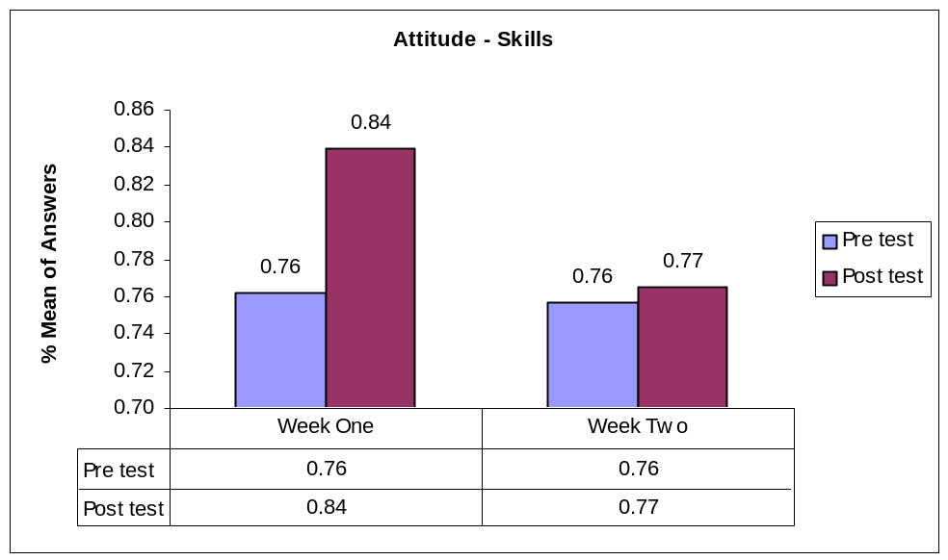

The personal interest category had increases in week one and week two. This could be based on the fact that the instructors did their job and made the camp interesting enough that the students could possibly enter the computer science field. The personal interest questions were based on if the students were interested in computer science. Looking at the chart we noticed that there was a three percent increase from week one pre/post test and a one percent increase from week two pre/post. Granted this is a small increase, but it is still an encouraging increase. Below is the data for these changes.

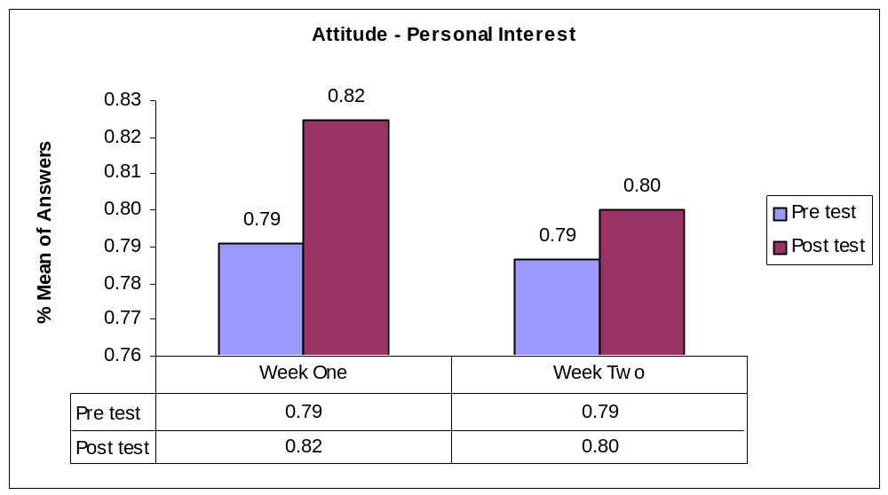

Image of computer scientists was a disappointment in week two but not in week one. Week one had a positive increase of three percent, while week two had no increase. Week two had a higher percentage of what a computer scientist should be in both the pretest and the posttest which indicates that before coming to the camp they already had a positive image of a computer scientist. It would have been nice to see an increase in this category, but knowing that they already have a good view of what a computer scientist is and they maintained it is also worthwhile.

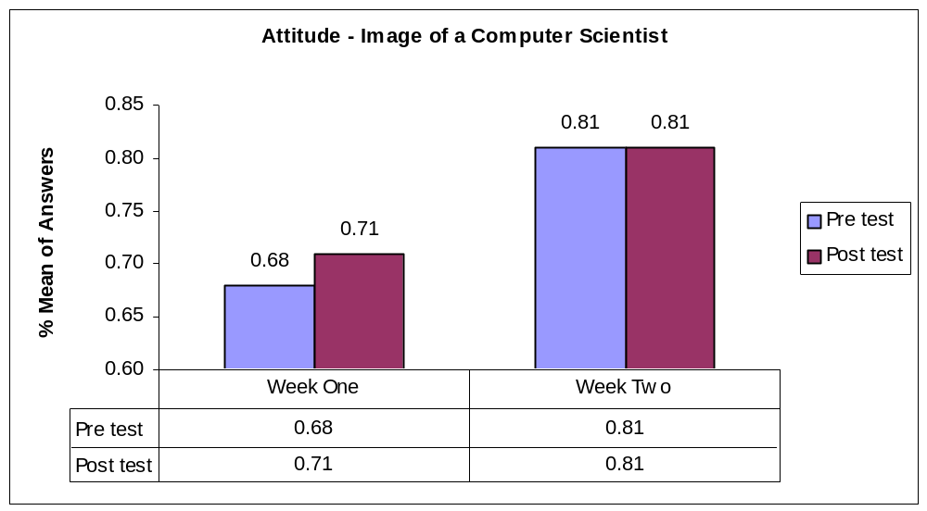
There was no test we could have administered to prove an increase in someone’s background so we decided to leave this category out. The data would have been inconclusive.
The whole purpose for using the two-tailed t-test is to get a p-value that we can compare to the alpha-level of significance. If the p-value is less than 0.05 we can say that our null hypothesis can be rejected. Otherwise the null is still plausible and cannot be rejected without further testing.
The chart below lists the category, week number, mean pretest, mean posttest and the p-value for the given week of camp.

Category | Week Number | Mean-Pre Test | Mean- Post Test | p-value
Technical | Week One  Week Two | 4.5  3.916 | 5.4  5.5 | 0.1754 not significant  0.0026 significant
Skills | Week One  Week Two | 8.38  8.33 | 9.23  8.416 | 0.2863 not significant  0.908553 not significant
Personal Interest | Week One  Week Two | 19.77  19.66 | 20.62  20.00 | 0.8636 not significant  0.644014 not significant
Image of a Computer Scientist | Week One  Week Two | 10.1530  12.083 | 10.6900  12.083 | 0.6340 not significant  1 not significant

Conclusion:
Week two showed much improvement from the pretest to the posttest in the technical portion of the pre/post test from the chart. We can reject the hypothesis that the means are equal because our p-value is less than the alpha-level 0.05, and we can also accept our alternative hypothesis, that the means between the tests are not equal. All the other p-values for the pre/post test were above the alpha-level and cannot be rejected and therefore it is still plausible that the means between the pre and posttest are equal. Even though the two- tailed t-test did not show significance in most of the categories there did seem to be positive increases in the majority of the areas. There was an increase in all areas except the second week’s image of a computer scientist, which remained constant. Since we had such a small sample size it is difficult to know if these findings are random, or due to some true effect of the camp. Further study with larger sample sizes would be beneficial in determining the actual affect the camp has on students, and it would also give a clearer picture of how girls learn differently when segregated.
When using this type of statistical testing to analyze a small data set, we have to consider that our data will not be modeled as well as a large sample size and it is less accurate. Also, because there is a lack of involvement with the students beyond the camp there attitudes cannot be accurately evaluated over a long period of time.

General Observations:
From observing the students during the two weeklong camps the instructors noticed that the boys were very rambunctious and the girls were very quiet. This was the case when the girls were segregated from the boys but when the girls were intermingled with the boys they acted as the boys would, rambunctious. In other words, the girls attitude when intermingled with the boys was poor and they had little interest in learning. The girls that were segregated had a better attitude and were anxious to complete given tasks. When it came to handling a task, the boys were more likely to talk in groups about the given task, while the girls were more apt to try the task on their own before getting into their selected groups. During the given task, the girls would ask questions if they had problems while the boys would give up and start a new task. It was also noticed that the girls were more detailed oriented in their program designs while the boys wanted to just blow stuff up or shoot something. When free time was available the girls worked on their programs, usually Alice, while the boys browsed the Internet or played video games.
The whole tone of the first camp was chaotic and stressful, whereas the second camp was more relaxed and quiet. The following is a list of other observations created by instructors during the camp.
- The students in week one all worked independently and asked us for help when they hit a problem while the students in week two often worked with each other and asked us for help only if the girl next to them couldn't fix it first
- The second camp returned to their projects often when they had free time while the first camp went to Internet games or movies when they had free time.
- The girls from both camps applied backgrounds that were more object-based, like dogs or Disney characters, and they were mostly from the Internet, while the boys chose backgrounds that were more shaped driven and from the preset options provided on the computer.
- The girls of both camps developed extensive environments and characters doing stories in Alice (using scenery we didn't even know existed) while the boys did short scenes with very little happening.
- The girls in the second camp chose usually harmless animals such as penguins, bunnies and fish for their Alice characters while the boys in the first camp chose the simpler scenery, and the characters were knights, dragons, samurais or sharks, more aggressive characters. The girls in the first camp seemed to have a mix of both personalities.
- The girls in the second camp seemed to prefer games that didn't require running everywhere (for lunch activities) while the boys preferred running and skill-based games. In addition, the girls in the first camp didn't play athletic games.
- During the lunch game of giants, wizards and dwarfs the second camp all chose the same thing a surprising number of times, but the boys from first camp almost always were different. (The game is a larger scaled version of rocks, paper, scissors where the kids strategize what is the best character to choose based on what they think the other team might be.)
- The second camp remained on task even if they got stuck, while the first camp would give up and do something else or play on the Internet if they got stuck.
- The second camp immediately gave the teachers their attention when it was requested, while the first camp had to be constantly reminded to give teachers their attention.
- The second camp would remain quiet during presentations, but the first camp would begin conversations and miss large segments of instruction.
- The first camp students all brought in their own music devices such as CD players and listened to them during presentations, but second camp students found music to listen to online and turned it off during instructions.
- On the scavenger hunt, the second camp really concentrated on solving and understanding the clues, while the first camp mostly just tried to get enough of the clue to run to the next station.
- The first camp’s students were more advanced with programming their robots and some of them could navigate through the maze, but the second camp was more concerned with aesthetics of the robot, many of them looking like people. They took longer to build, but didn’t move too much and none could make it through the maze.
- The girls in the second camp created puzzle video games, while the first camp created mostly shooting games.
- The first camp was marginally interested in insides of computers. They were more focused on what could harm other people, while the second camp’s girls were more interested in how things worked and what different pieces were.
- The first camp lost interest in the Lego challenge on computer day, while the second camp’s girls all helped out until the very end (though there were changes in the instruction of the activity that are also the reason for this).
- The second camp spent most time on Alice and robot Mindstorms, while the first camp spent most of their time on Games Factory and robot Mindstorms.
- “The second camp’s girls were quiet and asked a lot of questions on the bus rides, while the first camp’s students were absolutely unruly on the bus rides.” (Ewing, p. 1-2)
- During the first camp, all of the teachers were needed to help students to both stay on task and accomplish simple goals. During the second camp, only a couple teachers were needed to help students (they stayed on task on their own and simple goals were never issue: many of the girls went above and beyond to try new things and test the limits of the software).
Overall, the girls were more motivated to work when they were segregated from the boys. The girls that were intermingled with the boys were motivated but they were easily distracted from their task.

Conclusion and Future Directions:
After completion of the two camps we have noticed that when the girls are segregated from the boys, they’re more apt to learn and they have a better attitude toward the given task. The girls that were intermingled with the boys had little interest in the given task and were very sullen.
As far as future directions we think a broader study would be a more beneficial way to improve the camp. What we mean by broadening the study is to have more students over a longer period of time. If a longer time period and more students were used, one would acquire more data points, giving you a more accurate representation of the students’ interest and attitude.
References

Ewing, Michael and Tamara Hockett. Personal Interview. June 19, 2005.

Miller, Leanne. "Educational Software Considerations to Meet the Various Needs of
Middle School Mathematics Students." Master Thesis. (2005): 63-75.

Moskal, Barbara. “GK-12 Learning Partnerships: Creating Problem Centered,
Interdisciplinary Learning Environments.” GK-12 Learning Partnerships.
December 14, 2004. Colorado School of Mines. May 23, 2005
http://www.mines.edu/research/k12-partnership/.

Figure 1: Tech Camp 101 Schedule

Day | 10:00-11:00 | 11:00-12:00 | 12:00-1:00 | 1:00-2:00 | 2:00-3:00
Monday  Day 1 | - Introduction  - Ice breakers  - Rules  - Pretest | - MS Paint  - Logo design | - Lunch | - Logo design vote  - Alice introduction  - Alice project | - Alice project
Tuesday  Day 2 | - Inside computers introduction  - Inside computers | - Inside computers  - Computer trouble introduction | - Lunch | - Computer trouble  - Rocket science introduction | - Rocket science
Wednesday  Day 3 | - Video game introduction  - Video game project | - Video game project | - Lunch | - Cryptography introduction  - Cryptography hunt | - Cryptography hunt  - Ice cream social
Thursday  Day 4 | - Rocket Launching | - Robot introduction  - Robot project | - Lunch | - Robot project | - Robot project
Friday  Day 5 | - STUDENT CHOICE  - Alice project  - Video game project  - Robot project | - STUDENT CHOICE  - Alice project  - Video game project  - Robot project  - Posttest | - Lunch | - STUDENT CHOICE  1. Alice project  2. Video game project  3. Robot project  - Show and Tell prep | --OPEN HOUSE--  - Show and Tell  - Awards

Figure 2: 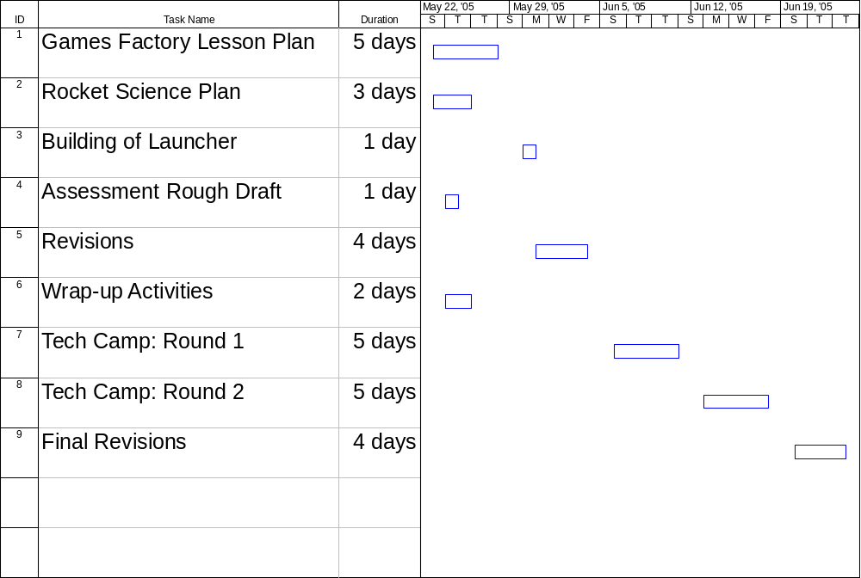Layout of Project
Figure 3: Tech Camp Plan
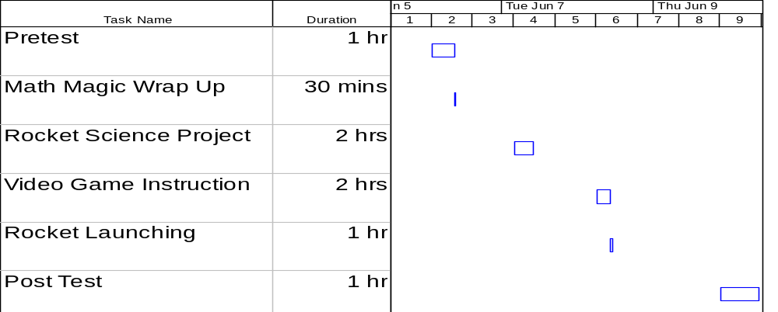

Appendix A:

Games Factory Plan
Objective:

To introduce students to the video game program Games Factory and allow students to create their own video games. In addition, students will be exposed to analytical thinking and logic skills used to solve common video game problems.
Introduction: Students will be shown the basic menus involved in Games Factory and shown how to drag and drop objects onto the level editor.
Making Breakout: Students will learn all the basic commands and options associated with creating a video game by walking through the tutorial game firstgame.gam and creating their own version of the game.
Optional Activities: Students who want to learn more from the program will be taught how to add sound, victory messages, lives, and score to their games.
Making Springy: Students will be allowed to showcase their skills by creating their own game from simple characters and backgrounds already loaded. Emphasize trial-and-error testing process for the kids, and let them enjoy the process by leaving them to enjoy this task on their own.
Shooting Games: For students who want to learn how to shoot objects as well as have enemies that fire objects.

Materials:

Games Factory program and toolkit, preloaded tutorial games called “firstgame.gam,” “springy.gam,” and “shootemup.gam.” The tutorial website http://myweb.tiscali.co.uk/screamproductions/index.html provides a good background of the program before teaching this lesson plan. This website serves as a great introduction into the program in addition to my lesson plan, and confidence in your ability with this program is essential to make the lesson work.

Procedure:

Note: If you are holding this class in Chauvenet Hall or any classroom that includes mice that have more than two click buttons, be sure to explain to the children to use the far left click and far right click.
Please “cut and paste” the sections below and distribute them to the students so they can follow along easily.

Introduction:
- Open the Games Factory by using start menu, going to Tech Camp 101, and clicking on the “Games Factory” icon. The program should open up and show a blank screen with the storyboard editor, showing one blank level.
- The storyboard editor is the main screen for the program, and the editor shows all the levels, titles, and passwords for levels that have been created thus far. You can access the storyboard view at any time by clicking the icon just to the right of the drop-down menu on the toolbar.
- Right-click the blank level, and select the “level editor” option, which follows from the “edit this level” option. This is the level editor, the most interactive screen in the program.
- From this screen, objects, characters, and backgrounds can be added to the game one level at a time. In this editor is one of the strengths of Games Factory, the preloaded image libraries.
- Load the “firstgame.gam” library; this is accomplished by selecting the “objects” header, then selecting “pick objects from a game.” After picking the file “firstgame,” you now have access to all the objects used in creating the game Breakout, the first game.
- Have some fun with dragging and dropping objects onto the level, then move into how to create the first game.

Making Breakout:
The game Breakout is a simple, pong-style game that will serve as an introduction on how to create video games. The game features a simple bat and bouncing ball, with which the player destroys bricks set into the game in order to win. First, make an introduction page.
- Choose your own color of background by choosing the “create new object” button, located just to the right of the events editor button. This button lets you create any type of object to be introduced into the game, from pictures to new animated characters.
- When the new window opens up inside the “create new object” window pick the quick backdrop icon, located in the top left section of the buttons displayed.
- A new window will open, from which you can pick the solid option, and choose any color shown in the panel to the right.
- Clicking “ok” on the menu will provide you with a colored small block on your level.
- Pick a point somewhere on your white canvas, and set the block by left clicking.
- There should be a block of your color on the level; set the block by clicking on the object and moving it to a corner of the white level.
- Letting go of the background should provide you with nine directional boxes, and clicking on a corner of one of them will allow you to resize the block to the full size of the level.
- Clicking outside of the borders of the object will take the focus off the object and allow more exploration.

Next, add a welcome screen.
- Go to the “create new object” button again, this time selecting the box with “ABC” in it. This is a text editor object, and it allows you to add the text to the screen as another object that can be modified.
- Clicking on the screen will add text wherever clicked. A “text options” panel is also displayed allowing you to change the font, size, position, and color of your text.
- Type a welcome message, and click the “ok” box in the option panel.
- The text can now be repositioned as you see fit on the level.

Next, add options to play the game or quit the game.
- Create two new text objects, one saying, “play the game” and one that says, “quit,” following the same methods already described. The only difference in this case is to make sure the two texts are different colors.
- Place them on the level, and now go back to “create new object.”

You can now make the objects interactive by placing small boxes next to the text.
- Click the running man box on the menu, and double-click on the blank box with a number “1” beneath it.
- A Microsoft paint-like interface with a small, colored box in the center should now be displayed.
- Paint the object, and click “ok” twice to exit out of the menus.
- Now place the box next to one of the text boxes.
- Repeat the process for the other text box.

You can animate your welcome menu.
- Go to the events editor button by clicking on the appropriate icon in the toolbar.
- A new screen will pop up with all the objects already made, plus a few new ones that will be explained later. The events editor guides the entire process of the program, making time-consuming and difficult things like collision detection and grouping much simpler.
- For now, simply right-click the area marked “new condition,” opening a new window with all the objects shown earlier now selectable.
- Ask yourself the question, “What do I want to do?” Write down the answer on a sheet of paper.
- In this case, when the mouse clicks on a box, you want to either start a game or end the game, depending on the box selected. Note that you will want to control an event created by the mouse when it clicks on an object.
- Right-click the icon that looks like a keyboard and mouse.
- Two options will appear, select “the mouse” option, followed by the “when the mouse clicks on an object.”
- Select that option and a new window will appear that allows you to select one of the two boxes we already created.
- Pick one, and the window will close, and a new row of the table will be added, allowing users to control the event that will occur when the object is clicked.
- Next, right-click under the space provided with the film image, which is the storyboard editor control.
- Depending on the option of the box selected, either choose jump to level (for “play the game”) or end the game (for “quit”).
- A dot will now be placed in the box, indicating that the object will comply with that demand.
- Repeat this process for the second object and the title screen for the game is finished.
- Give the level a quick test by running it. Selecting the “run level” option from the toolbar on the far right does this.
Do not panic if the game closes after pressing either option, this is the correct effect.

Finally, we can now move on to creating the actual game.
- To start with, click the storyboard icon in the toolbar to bring the storyboard editor back up.
- Add a title to the first level, and now add a new level by right clicking the “more…” box underneath the level.
- Click the top tab that appears, and open up the new level that has appeared on the screen into the level editor.
- Now, add objects from the object menu, located to the left of the screen.
- Add a new background to the level, and add a ball and bat to the screen by pulling the objects from the object toolbar.
- Movement can be added to the objects by right clicking each one and choosing “select movement.”
- For the ball, select the bouncing ball option and set the randomizer of the path of the ball to zero, located under the “bounces” tab.
- In addition, under the “initial direction” tab for the ball, set the initial direction to a semi-circle, facing up. This action will keep the ball from passing the bat without proper game play later on.
- The bat’s movement will be controlled by the keyboard, so click the “eight directions” option.
- From here, click the “directions” tab and remove all directions of movement except left and right by clicking the small squares around the circle.
- Run the level by pressing the “run level” button. Notice that the ball flies off the screen and the bat can be moved off. This is because you have not told the game to bounce the ball and stop the bat at the edges of the level.
- Go into the events editor again, and make new conditions for each object.
- Start with the ball by selecting it as the object using a right-click. A number of options should appear.
- Go to “position,” and select the “test position of ball.” A new window will open up with a variety of arrows that are available.
- Click the inside arrows that are pointing outside the screen. This option tells the game that when the ball tries to leave the screen, an event will happen.
- Now, an extra row has been added to the table, giving an option for what the ball will do when leaving the playing area.
- Right-click the square under the ball picture, and you should select “movement” and “bounce” from the menus. This tells the game to bounce the ball around the playing area, keeping it within view.

The next step is to program the movement of the bat.
- Select the bat object, and again select the “test position” option.
- This time however, only select the left and right inside arrows. Choose these options because the bat is only programmed to move in two directions, left and right.
- Once another row on your event table is shown, right-click the box under the bat.
- Since you want the bat to stop moving at the borders, select “movement” and “stop.”
- Test the conditions by running the level again. The ball will bounce off all the walls, and the bat should move back and forth across the screen according to keyboard control, stopping at the edges.

Why is the ball passing through the bat? The answer is that the program has not been told to interact with the bat and ball yet.
- To function correctly, the ball should bounce off the bat whenever the two objects collide.
- Exit out of the game by pressing the red X in the corner of the screen, and go back to the events editor.
- Since ball is the subject of the sentence, select the ball first.
- Right clicking the ball object will give the same options again, but now select “collisions” and “collision with another object.”
- Select the bat and another row of the table should show up.
- Click under the ball’s box, and select the option to make the ball bounce off the bat.
- Run the level again. The ball should bounce off the bat now.

Next, we need to place the enemies of the game, the bricks.
- Go back to the level editor, and add some of the colored bricks from the object toolbar provided.
- Note that multiple bricks of the same color can be added by using the right-click instead of left-click button.
- Add some bricks of each color to the game, making sure to space them appropriately and creatively.
- If you have trouble spacing bricks, go to the “preferences” button on the toolbar, click the “grid” tab, and check the “snap to” and “show grid” sections on the new window.
- Exit, and the game should have a neat row of dots to line up bricks.
- Go back to the events editor to set up the actions for the bricks.
- Notice that each color brick has its own column. These columns each correspond to the blocks of that color. All same-colored blocks will act the same way as determined by you. This is another strength of the Games Factory program, grouping objects.
- The block should be destroyed by the ball whenever the two collide. To do this, select the ball again from the new condition window, and again pick the “collision with another object,” picking a type of block this time.
- On the new row, click the block picked, and select “destroy” from the menu.
- In addition, the ball should bounce off the brick after it hits. To do this, select the ball under the same row and click the “bounce” movement again.
- Repeat this process for all the different colors of blocks.
- Run the level again, and the ball should both bounce and destroy the blocks created.

Congratulations, you have just created your first video game!

Optional Activities

Now you should have the start of a good game. What happens when all the blocks are destroyed? Can some music be added?
Where is the score? Where are the lives? These objects can now be added.
- First, add a number of lives to the game for the bat.
- Pick the little man icon from the toolbar, (the toolbar may have to be moved down by pressing the blue arrow on the left edge to find it) and add him to the screen in the bottom left side of the level. This object is the lives’ indicator.
- Pick the “123” object off the toolbar and place it in the bottom right of the screen. This will be the game’s scorekeeper.
- Click back to the events editor screen and add the objects’ interactivity.

How will the player die? Typically, a life is taken when the ball disappears below the bat. This will be tricky, since the ball is already set to bounce off the bottom.
- However, it can be accomplished by right clicking the ball condition that is already set up and click “edit.”
- A familiar position screen will show up, and now you can unselect the bottom arrow, letting the ball pass through the bottom of the screen.
- You must program the game to subtract a life every time the ball leaves the bottom of the screen.
- Add a new condition for the ball, clicking the “position” again and selecting the bottom arrow.
- With the new row, subtract a life by right clicking under the joystick box and picking the “subtract from number of lives” option.
- Pick one life, and press ok. Now when the ball gets past the bat, a life will be subtracted.
- The level must now restart each time a life is subtracted. To do this, go under the same row, select the storyboard box, and pick “restart current level” as the option. The level will restart after each death.
- Next, a condition is needed for when there are no lives left. Picking the joystick object this time, select “compare to number of lives” and pick “equal to zero” from the window.
- When the last life is gone, the game should go back to the title screen. To accomplish this, pick the storyboard box and select the “restart the game” option. Now the game restarts to the title screen when the lives are at zero.

Now, program the scoring of the game.
- Whenever a brick is destroyed, the score should increase a certain number of points, depending upon each type of brick. This is done by going back to the rows where the bricks are destroyed and right-click on the joystick box again.
- Select the “score” and “add to score” options, and choose a score to add to the total for each brick.
- Repeat this process for all the different bricks, and make sure to vary the scores for each one.
- Run the level again, and play it all the way though. Is anything not working?

The only objects left to add to the game now are sound and a victory message.
- Sound can be added as easily as the score was added by right clicking under the speaker box for each object that will be heard.
- Choose the “play sample” option offered, and make sure to open the “samples” folder that is shown. You can now pick any samples you want to include in your game.
- To test the sound easily, click a sound once, then press the “play” button on the menu.
- Try adding different samples of sound for each type of brick.

The victory message is a bit different.
- Go back to the level editor and add another text object saying, “Well done!”
- After clicking “ok,” right-click the text box and choose the “make invisible” option. This will hide the text as a gray ABC box until it is needed.
- In addition, right-click the text and choose the “object preferences” option.
- From here, choose the “advanced” tab and uncheck the “save background” option. This allows the text to be displayed when an event occurs, such as winning the game.
- Next, the text should be displayed after all the bricks have been cleared. To accomplish this, group the bricks into one group, called group “bad.” This is accomplished by right clicking one of each type of brick, and selecting “object preferences.”
- From here, select the “object handling” tab and click the “add” button under the “objects qualifier” section.
- Choose the group “bad” icon, and exit the menu by pressing “ok.” Doing this to each color of brick will group all the bricks into the group “bad” section. With that done, move into the events editor for the final action of the game.
- Select the group “bad” icon for the object to test and select the “compare to number of objects” option.
- Setting the number to “zero” indicates that all the bricks will be destroyed when the action occurs.
- Click the text box in the row and choose the “display text” option.
- This will show the level editor to choose the location of the text to be displayed.
- Take the “X”ed box and place it over the gray “ABC” box already on the screen.
- For a final touch, go to the bat and ball boxes and select “visibility,” “make invisible” on the same row.
- Finally, make sure to also select the ball to stop moving after the game is over, to stop the ball from restarting the level accidentally.
- Run the level a final time, making sure everything works.
- If all went okay, go ahead and choose the “run game” option, the icon just to the left of the “run level,” and play the new game completely.

Making Springy:
Since you have a basic understanding of the Games Factory program and its functionality, you can now be given the task to create your own adventure game using some basic backgrounds, characters, and objects.
- Open the Springy game by clicking on the “open” button from the toolbar and selecting the “springy.gam” game file.
- Run through the game once by pressing the “Run Game” button next to the run level button.
- Edit the third level, and again select “pick objects from a game” option from the objects heading.
- Select “springy” from the list of available games, and an object toolbar should pop up on the left of the screen.
- All the pre-loaded objects will be available from this area, including the pieces of the background.
- Explore and have fun with the game, creating your own levels and puzzles with the software.

Shooting Games:
Making an object shoot another object is simple; this is how it is done!
- Add two objects to your level, one to shoot at and one to shoot.
- Go to the events editor, select “new condition,” picking the keyboard choice, followed by “upon pressing a key.”
- Choose a key to shoot with, and press it.
- A new row is formed for you to create an action (and sound) for when the key is pressed.
- Right-click your shooter, and choose the “shoot an object…” option.
- You will now have to choose the object to be shot. Choose a suitable object from a library and click ok. Note: bullets and lasers have sections they are divided into. Three sizes of lasers are available, and bullets are found in “game objects 3.”
- A new window will pop up asking for a speed of the bullet as well as the direction the bullet should travel. Try changing speeds later but leave the default settings for both this time.
Your character will now shoot an object whenever that button is pushed.
- Add a “destroy” command for when your dummy gets hit by the bullet. Follow the same steps used for the bricks in Breakout.
- Add movement to your shooter and victim.
- Test your level, making sure all runs smoothly.
Nice Job! You have made your first shooting game! Keep Practicing!!

Conclusion:

The goal of this project is that the students have experienced the process of analytical thinking and use of logic to defeat common problems set by video game programming. In addition, the children have had significant experience with the Games Factory program and have created their own games as a result. To conclude the project, children will be able to save their games as stand alone executable files on a CD for future use. Students will also be able to save their games as Internet games, allowing them to incorporate their programs into future work at our advanced camps. The staff of Tech Camp 101 hopes that these teachings and gifts will increase the students’ interest in video game programming and other technological areas.
Appendix B:

Bottle Rocket Science

Objective: To explore the effects of pressure and amount of water used in bottle rockets.
Students will discover changes in flight patterns of their bottle rockets depending on how much water the rocket holds and how much pressure is pumped into the rocket. Then, students will be able to create their own rocket from a two liter pop bottle and have a chance to launch them.

Materials:
Prep: Glass of water
Index card
Balloon
Free software from http://www.seeds2learn.com/rocketSoftware.html
Rocket: 2-liter plastic soft drink bottle
Low-temperature glue gun
Poster board
Tape
Modeling clay
Scissors
Rulers
Decorations of students’ choice
Launcher: Measuring cup
4 5-inch corner irons with 12 ¾ inch wood screws to fit
1 5-inch mounting plate
2 6-inch spikes
2 10-inch spikes or metal tent stakes
2 5-inch by ¼ inch carriage bolts with six ¼ inch nuts
1 3-inch eyebolt with two nuts and washers
4 ¾ -inch diameter washers to fit bolts
1 Number 3 rubber stopper with a single hole
1 snap-in tubeless tire valve (small 0.453 inch hole, 2 inch long)
Wood board 12 by 18 by ¾ inches
Electric drill and bits including a 3/8-inch bit
Screwdriver
Pliers or open-end wrench to fit nuts
Vice
12 feet of ¼ inch cord
Bicycle pump with pressure gauge

Before Students Arrive:
- Download the rocket software from website and unzip it into the “Tech Camp 101” folder in “My Documents.”
- Prepare glass of water “trick” and balloon demonstration.
- Build launcher.
- Have supplies ready for building the rockets, as well as decorations.

Procedure:
Start by reviewing the basics of force and pressure. To demonstrate the concepts of pressure use a glass, half to completely full of water and place an index card over the top. Then place a hand over the index card and invert the glass. Slowly remove your hand, leaving the index card and glass upside down. The water shouldn’t spill out because the air pressure outside the glass is greater than the pressure inside. This gives a basic understanding of air and water pressure that will be needed to explain how the bottle rockets launch.
To explain force in the context of Newton’s Third Law, “for every action, there is an equal and opposite reaction,” use a balloon. When the balloon is full of air and in an equilibrium state, it does not need to move. As air is released from the balloon, the balloon moves in the opposite direction than the air does. To help with this demonstration, it is possible to tape a straw to the side of the balloon and thread it through a string. Attach the string to a wall and either hold the other end, or have a student hold it. Then release the balloon. The balloon should fly along the string instead of randomly around the room. This demonstrates the motion of the rocket. As water is leaving the rocket, the motion of the rocket is in the opposite direction. The rocket moves because of the air pressure that is pumped inside the rocket. As the pressure is increased it pushes the water out of the bottle. While the air is pushing on the water, the water is also pushing on the air, moving the bottle in the opposite direction of water loss.
Once the basic concept of pressure and force is explained, students can explore the effects of different amounts of pressure applied to the system and the amount of water that is put into their rockets using the software provided at http://www.seeds2learn.com/rocketSoftware.html. This allows students to adjust values and quickly see how high and what path their rockets should take during flight. Students may want to experiment with other options in the program, such as the gravity field or the drag coefficient. Allow the students to play with the software, but remind them to return to the initial setting before deciding on values to use for their rockets.
Split students up into groups and allow them to find a value for the percent of water and a pressure that will give the children the maximum height for their rocket. Since the program works based on a percentage of water that fills the rocket, also have the students calculate how much water the value corresponds to in milliliters. Briefly discuss how to calculate the amount of water by walking through the conversion of 2 L to 2000 mL. Explain to the students that they need to multiply the percent by 2000 to obtain the amount of water in milliliters that each group intends to use.
Once the groups have decided on the values, construction of the rocket can begin. Have students measure around the outside of the bottle to find where the fins should be placed to have the fins equally spaced around the rocket. One way to do this is to wrap the bottle with a piece of paper or string and mark the circumference of the bottle. Measure the distance and divide it into three equal parts. Put the paper or string back on the bottle and mark the new divisions that indicate the three equidistant points where the fins should be applied. Using the low-temperature glue gun, attach the fins to the bottle. Tape can be added for additional support, making it less likely that students will lose their fins during launching. Next, have the students form the nosecone. The nosecone can be held together with either tape or glue. Add a small amount of modeling clay into the top of the nosecone in order to increase the stability of the rocket. Finally glue or tape the nosecone to the top of the bottle, and allow students to decorate their rockets if time permits. (Possible fin and nosecone designs are attached).
For launching the rockets, have students stand back and only allow the individual groups to approach the launching area when it is their turn. Have the students’ fill their bottles with the amount of water they desire, and also pump the rocket to the pressure they want to attempt. Have the group count down for their rocket to launch and also have a member of the group time the rocket’s travel to the maximum height. The time can be used after the students are done launching to see how high their rockets actually went, and compare this value to the one predicted by the software. The launcher itself can either be purchased or built with basic tools according to directions found at http://www.nasa.gov/pdf/58269main_Rockets.pdf. The directions are also attached for ease of building.
Calculating the height of the students’ rockets based on the time can be done with the following equation: y (t) =1/2 *(32.2 ft/sec) * (t) ^2 where y (t) is the vertical height and t is the time traveled to maximum height. The formula reduces to [16.1* t^2] which should equal the height of the rocket in feet. Students may have difficulty understanding the formula, and stepping them through it may be beneficial.
After launching is complete, students should compare their actual values to their predicted values. What could cause differences in these values? Perhaps weather conditions, loss of water during launching, not accurate pressure amount. Let the students brainstorm more possibilities! Also, a brief brainstorming session of ways to increase experimentation skills can be discussed. For example, what would happen if you held one value constant, and adjusted the other? Would this make it easier to see the effect of the value you’re adjusting? This is a fun way to introduce the beginnings of the scientific method.

Launcher Suggestions:
Some problems may arise with heavy use of the launcher. A thin, bendable mounting plate will deform under the pressure of placing bottles into position, so make sure to use thick metal (around ¼”). A thin plate creates an uneven surface for the bottle to sit on while being pressurized and increases the risk of the bottle launching before its intended time. Another area of concern is the stopper that blocks the water. After heavy use, the stopper may have lost some of its sealing ability, and it should be replaced to reduce the amount of water lost while pressurizing the rocket. The last issue is with the pin, or nails, that hold the bottle in position while pressurizing the rocket. If these bend during use, be sure to replace them. If they do not secure the lip of the rocket properly, the rockets tend to shoot off the launch pad sideways before intended.
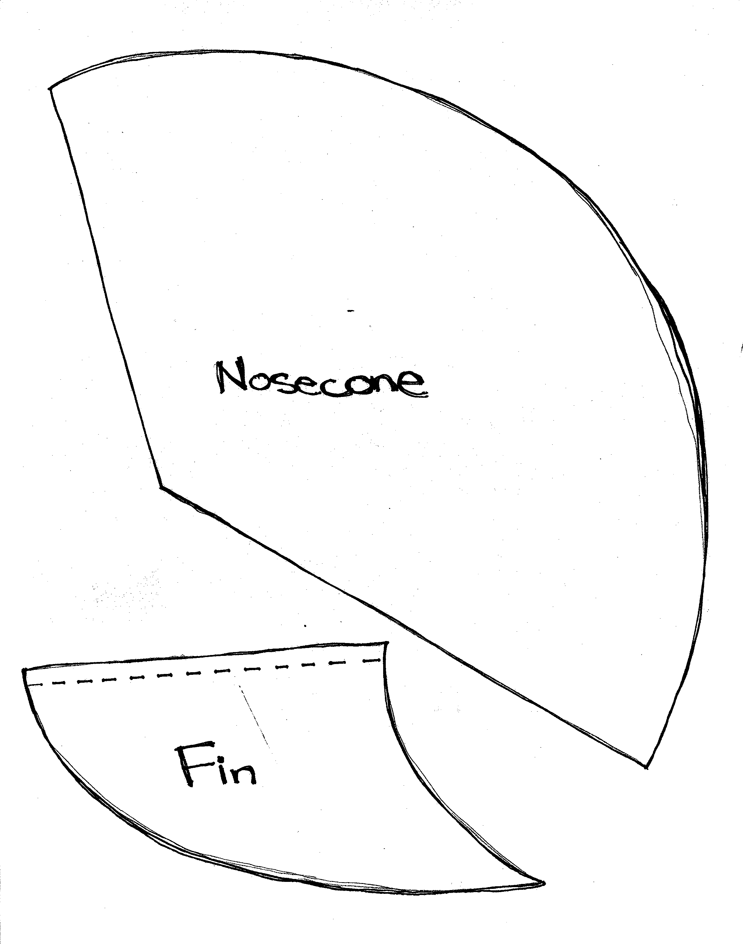
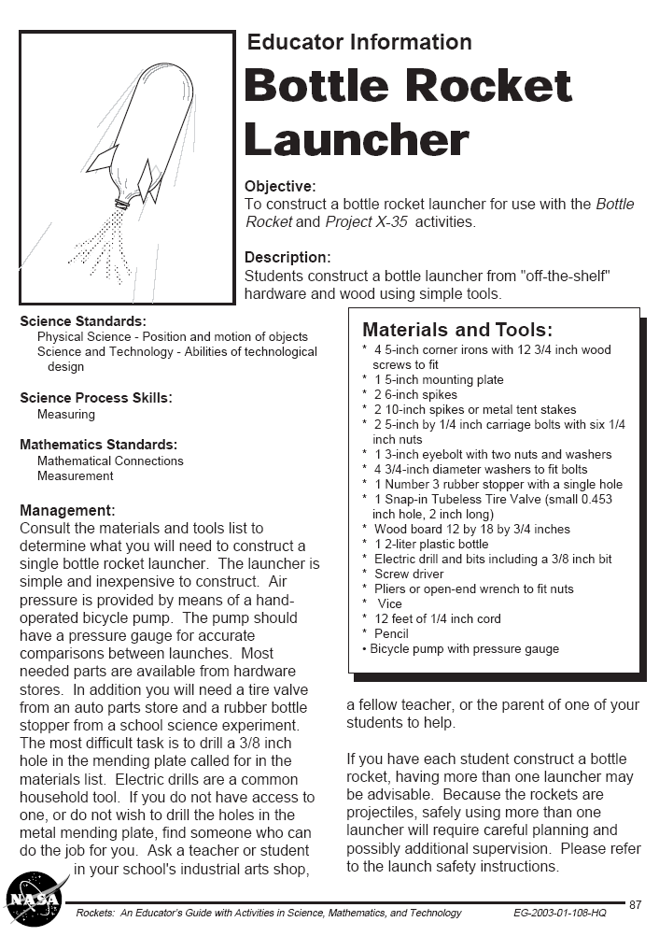

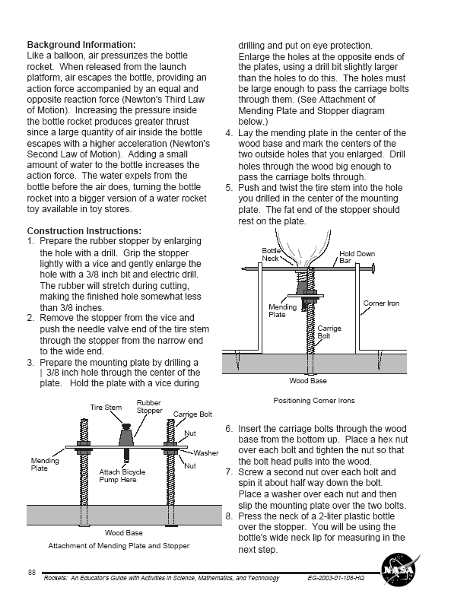
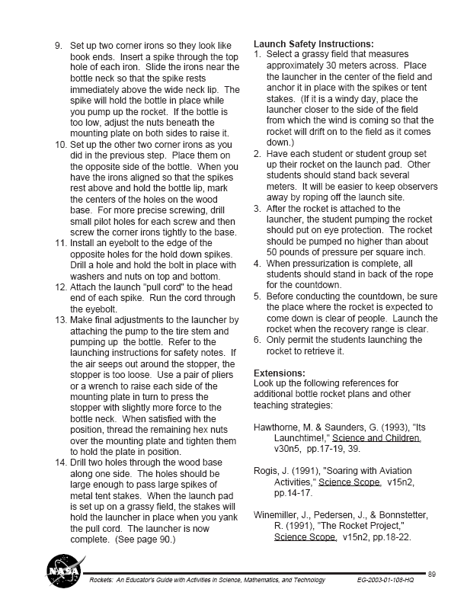
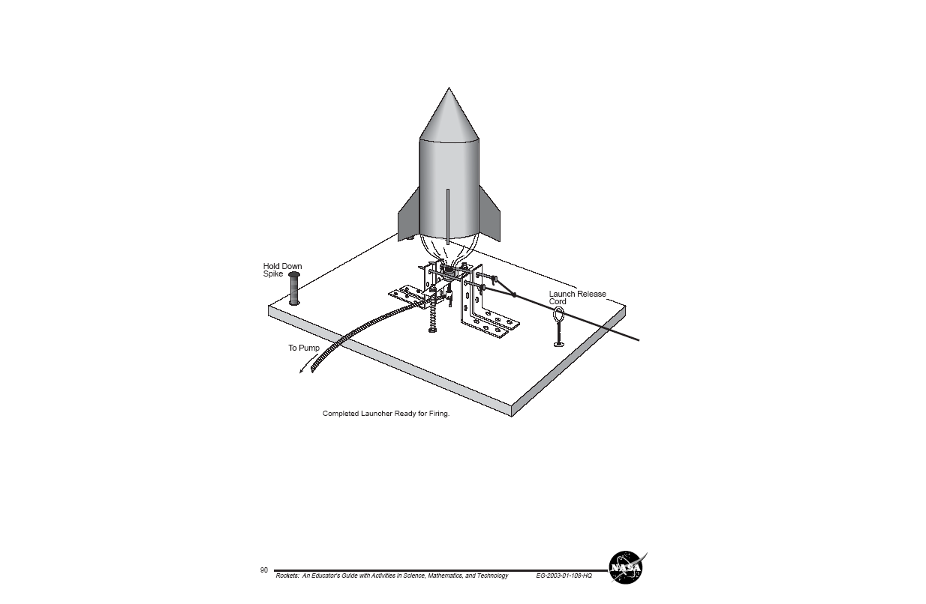
Appendix C:
PRE-POST TEST

1. Do you want to go to college after high school?
- Yes
- No
- Not sure

2. What is the most important step when programming a video game?
- Making the game colorful
- Adding cool objects
- Exploding things
4. Testing the game

3. How many hours do you spend each week on a computer?
- NONE
- 1-2 hours
- 2-3 hours
- More than 3 hours

4. Today, binary code is a form of cryptography, but what is it used for?
- To confuse computer-illiterate people.
- To represent all physical information in the digital world so the computer can understand and process it.
- To make every letter a number.
- To convert bigger numbers into smaller numbers so the computer will process faster.

5. Please indicate your agreement with the following statement.
Computer scientists help people.
1. Strongly Agree
2. Agree
3. Neutral
4. Disagree
5. Strongly Disagree

6. What type of file is a video game usually saved as on a computer?
- Document file (*.doc)
- Video file (*.avi)
- Bitmap file (*.bmp)
- Executable file (*.exe)

7. Please indicate your agreement with the following statement.
Computer scientists are nerdy.
1. Strongly Agree
2. Agree
3. Neutral
4. Disagree
5. Strongly Disagree

8. Please indicate your agreement with the following statement.
Boys are better than girls at using the computer.
1. Strongly Agree
2. Agree
3. Neutral
4. Disagree
5. Strongly Disagree

9. Please indicate your agreement with the following statement.
I like working on the computer.
1. Strongly Agree
2. Agree
3. Neutral
4. Disagree
5. Strongly Disagree

10. Why do straws work?
- Change in air pressure
- I don’t know
- Magic
- Stickiness of liquid, it “climbs” up the straw

11. Please indicate your agreement with the following statement.
Most computer scientist’s work by themselves all day.
1. Strongly Agree
2. Agree
3. Neutral
4. Disagree
5. Strongly Disagree

12. What will the bunny in the code below do?
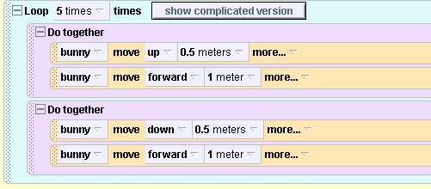
- “Hop” by making the up and forward and the down and forward movements at the same time
- Move up, then forward, then down, and then forward again five times.
- “Hop” five times by making the up and forward movement and then the down and forward movement.
- Move forward 2 meters in one action.

13. Choose the statement that best describes you:
- I like computer science better than math.
- I like math better than computer science.
- I don’t like math or computer science.
- I like math and computer science the same amount.

14. Do you think computer programming will help you in college?
- Yes
- No

15. Who is better at using a computer?
- Girls
- Boys
- Both

16. Please indicate your agreement with the following statement.
I want to be a computer scientist when I grow up.
1. Strongly Agree
2. Agree
3. Neutral
4. Disagree
5. Strongly Disagree

17. Please indicate your agreement with the following statement.
I am good at using computers.
1. Strongly Agree
2. Agree
3. Neutral
4. Disagree
5. Strongly Disagree

18. Please indicate your agreement with the following statement.
I like computer science.
1. Strongly Agree
2. Agree
3. Neutral
4. Disagree
5. Strongly Disagree

19. Which of the following areas is your favorite?
- Cryptography
- Programming
- Fixing computers
- Robotics
- Graphics and animation
- Video game creation

20. If you were to jump off the end of a skateboard, it would travel in the _____ direction of your jump.
- Same
- Opposite

21. Do you think computers help you to learn?
  - Yes
  - No

22. The most common problems in computers occur because a cable is not connected in the right location. Which one of the following changes to computer cables does not help avoid this problem?
- Assigning pronged ends to the cables and slotted ends to the computer.
- Using a specific alignment of pins that allow a cable to only be plugged in a certain way.
- Colorizing the cables to match the location they get plugged into on the computer.
- Lengthening the cables from three feet to six feet so they reach farther.

23. What is your skill level on a computer?
- Below average
- Average
- Very good
- Superior

24. Do you have a computer at home?
- Yes
- No

25. Please indicate your agreement with the following statement.
I want to go to college in math or science when I’m older.
1. Strongly Agree
2. Agree
3. Neutral
4. Disagree
5. Strongly Disagree

26. The central processing unit (CPU) on a computer is most similar to:
- The Lego Mindstorms RCX
- The Lego Mindstorms battery
- The Lego Mindstorms motor
- The Lego Mindstorms touch sensor

This question may need to be asked: but we’ll need it on paper. We can’t use the clickers to answer it.

27. Please draw a picture of a computer scientist in the space below.
Appendix D:

Math Magic Plan

Objective: A fun look at number patterns and a brief introduction to basic algebra.
By using simple word problems, students can see how algebra can be used in a real life example.

Materials: A deck of cards

Procedure:
First activity: a fun way to show patterns with numbers.
Ask the students to pick a number between one and nine.
Have a list on the board of what value will correspond to their number.
The list is just the numbers 1-9, multiplied by 9.
1->9
2->18
3->27
etc.

Have the students multiply the number 12,345,679 by the value above.
For example if the student chose two, they should multiply 12,345,679*18.
Have them look at the answer, in this example it is 222,222,222. A row of the number they originally chose!

This works because you’re working with multiples of nine.
12,345,679*9 = 111,111,111. So when you multiply 9 times a chosen number between 1 and 9, and then multiply that number by 12,345,679, it is essentially doing the same multiplication as 111,111,111 times the number between 1 and 9, giving you a row of the number you chose.

Second activity: a brief look at algebra
Have the students:
- Think of a number
- Add 5
- Multiply by 3
- Subtract 3
- Divide by 3
- Subtract their original number.
- Map the digit to a letter in the alphabet; that is 1=A, 2=B, 3=C, etc.
- Pick the name of a country in Europe that begins with that letter.
- Take the second letter in that country’s name and think of an animal that begins with that letter.
- Think of the color of that animal.

At this point ask how many students are thinking of a gray elephant from Denmark. A surprising amount should be! Repeat steps 1 through 6 and show students that you end up with 4 every time.

This works because of very basic algebra. To explain the “trick” it could be helpful to show a table like the one below as you’re going through the problem.

Directions | How the Numbers Change | Algebraic Expressions
Think of a number | 2 | 7 | 15 | n
Add 5 | 7 | 12 | 20 | n+5
Multiply by 3 | 21 | 36 | 60 | 3n+15
Subtract 3 | 18 | 33 | 57 | 3n+12
Divide by 3 | 6 | 11 | 19 | n+4
Subtract your original number | 4 | 4 | 4 | 4

If the students feel able to, let them try to make up their own math magic problem!

Third Activity: a challenge problem in algebra

Have a student pick a card from the deck of cards. Have them show the entire class the card. Also have the following chart on the board for students to refer to:

Card Numbers Value of Suits
Ace=1 Clubs=1
2=2 Diamonds=2
3=3 Hearts=3
… Spades=4
10=10
Jack=11
Queen=12
King=13

Have the students:
- Take the card’s number
- Add the number that is one more than this number. For example if the card was a 2, add 2+3.
- Multiply that result by 5.
- Add the value of the suit to that answer. (Hearts=3)
- Add 637 to that result and have them tell you the number.

In your head you now subtract 642. Looking at the final result you can figure out what card the kids started with. The tens digit corresponds to the number of the card and the ones digit is the suit number. For example if the final value was 73, the card was a seven of hearts. If the number was 121. The card was a queen of clubs! Try this several times depending on time, and then let students know that you are subtracting another number and show them how to read the results.

The “trick” works in a similar way as the second activity. But it is a more complex algebraic expression, and instead of working through it, it could be suggested as a challenge problem for those that want to try it at home.

Direction | How the Number Changes | Algebraic Expression
Take the card’s number | 7 | x
Add the number that is one more than this number | 15 | x+x+1= 2x+1
Multiply that result by 5 | 75 | 10x+5
Add the value of the suit to that answer | 78 | 10x+y+5
Add 637 to that result | 715 | 10x+y+642
Subtract 642 | 73 | 10x+y

Since you will always end up with 10 times the card number plus the suit value, you can read off the answer by looking at the tens unit and ones unit separately to figure out any card in the deck!
Appendix E:
PRE-POST TEST with Likert Scale
Number Assigned
1. Do you want to go to college after high school?
3 1. Yes
2 2. No
1 3. Not sure

2. What is the most important step when programming a video game?
0 1. Making the game colorful
0 2. Adding cool objects
0 3. Exploding things
1 4. Testing the game

4. Today, binary code is a form of cryptography, but what is it used for?
0 1. To confuse computer-illiterate people.
1 2. To represent all physical information in the digital world so the computer can understand and process it.
0 3. To make every letter a number.
0 4. To convert bigger numbers into smaller numbers so the computer will process faster.

5. Please indicate your agreement with the following statement.
Computer scientists help people.
5 1. Strongly Agree
4 2. Agree
3 3. Neutral
2 4. Disagree
1 5. Strongly Disagree

6. What type of file is a video game usually saved as on a computer?
0 1. Document file (*.doc)
0 2. Video file (*.avi)
0 3. Bitmap file (*.bmp)
1 4. Executable file (*.exe)

7. Please indicate your agreement with the following statement.
Computer scientists are nerdy.
1 1. Strongly Agree
2 2. Agree
3 3. Neutral
4 4. Disagree
5 5. Strongly Disagree

9. Please indicate your agreement with the following statement.
I like working on the computer.
5 1. Strongly Agree
4 2. Agree
3 3. Neutral
2 4. Disagree
1 5. Strongly Disagree

10. Why do straws work?
1 1. Change in air pressure
0 2. I don’t know
0 3. Magic
0 4. Stickiness of liquid, it “climbs” up the straw

11. Please indicate your agreement with the following statement.
Most computer scientist’s work by themselves all day.
1 1. Strongly Agree
2 2. Agree
3 3. Neutral
4 4. Disagree
5 5. Strongly Disagree

12. What will the bunny in the code below do?
0 1. “Hop” by making the up and forward and the down and forward movements at the same time
0 2. Move up, then forward, then down, and then forward again five times.
1 3. “Hop” five times by making the up and forward movement and then the down and forward movement.
0 4. Move forward 2 meters in one action.

13. Choose the statement that best describes you:
1 1. I like computer science better than math.
1 2. I like math better than computer science.
0 3. I don’t like math or computer science.
1 4. I like math and computer science the same amount.

14. Do you think computer programming will help you in college?
2 1. Yes
1 2. No

16. Please indicate your agreement with the following statement.
I want to be a computer scientist when I grow up.
5 1. Strongly Agree
4 2. Agree
3 3. Neutral
2 4. Disagree
1 5. Strongly Disagree

17. Please indicate your agreement with the following statement.
I am good at using computers.
5 1. Strongly Agree
4 2. Agree
3 3. Neutral
2 4. Disagree
1 5. Strongly Disagree

18. Please indicate your agreement with the following statement.
I like computer science.
5 1. Strongly Agree
4 2. Agree
3 3. Neutral
2 4. Disagree
1 5. Strongly Disagree

19. Which of the following areas is your favorite?
1 1. Cryptography
1 2. Programming
1 3. Fixing computers
1 4. Robotics
1 5. Graphics and animation
1 6. Video game creation

20. If you were to jump off the end of a skateboard, it would travel in the _____ direction of your jump.
0 1. Same
1 2. Opposite

22. The most common problems in computers occur because a cable is not connected in the right location. Which one of the following changes to computer cables does not help avoid this problem?
0 1. Assigning pronged ends to the cables and slotted ends to the computer.
0 2. Using a specific alignment of pins that allow a cable to only be plugged in a certain way.
0 3. Colorizing the cables to match the location they get plugged into on the computer.
1 4. Lengthening the cables from three feet to six feet so they reach farther.

23. What is your skill level on a computer?
1 1. Below average
2 2. Average
3 3. Very good
4 4. Superior

25. Please indicate your agreement with the following statement.
I want to go to college in math or science when I’m older.
5 1. Strongly Agree
4 2. Agree
3 3. Neutral
2 4. Disagree
1 5. Strongly Disagree

26. The central processing unit (CPU) on a computer is most similar to:
1 1. The Lego Mindstorms RCX
0 2. The Lego Mindstorms battery
0 3. The Lego Mindstorms motor
0 4. The Lego Mindstorms touch sensor

